**Task 1**

* How did you use connection pooling?

First I add Data resources in context.xml,

. And then I write resource ref in web.xml. Finally change the dbcon objects using data source defined in web.xml.

* Snapshots
* File name, line numbers as in Github

Webcontent/META-INF/context.xml

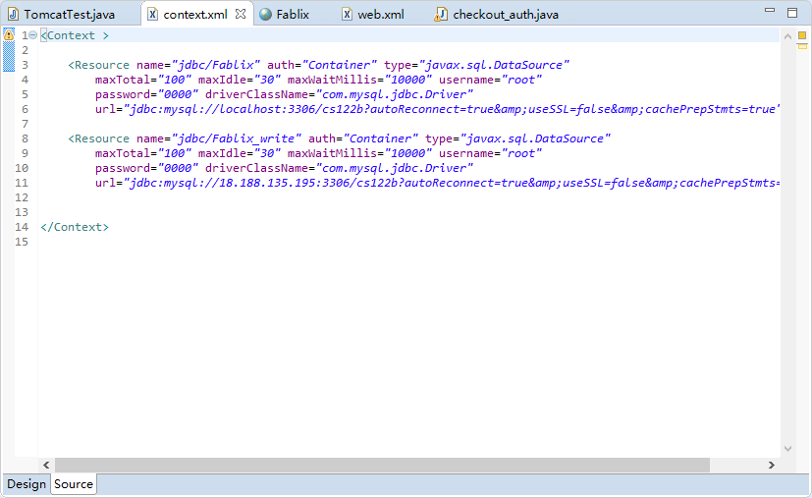

Webcontent/WEB-INF/web.xml

* 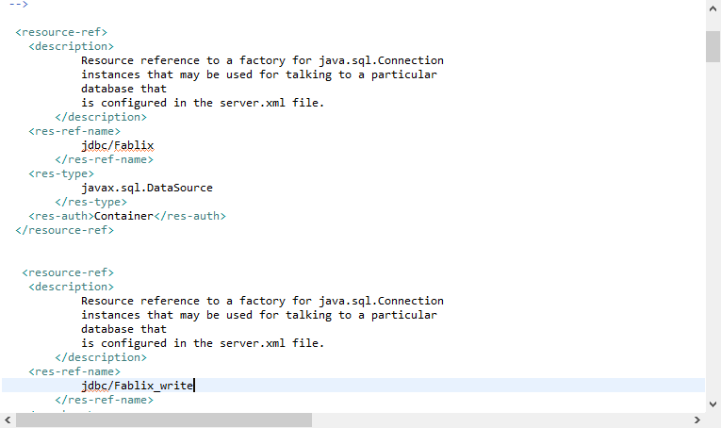

dashboard_insert_movie.java 65-78

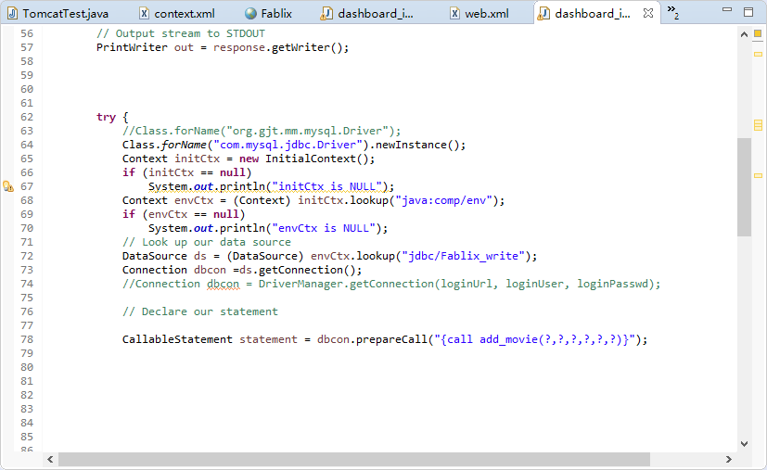

dashboard_insert_star.java (64-77)

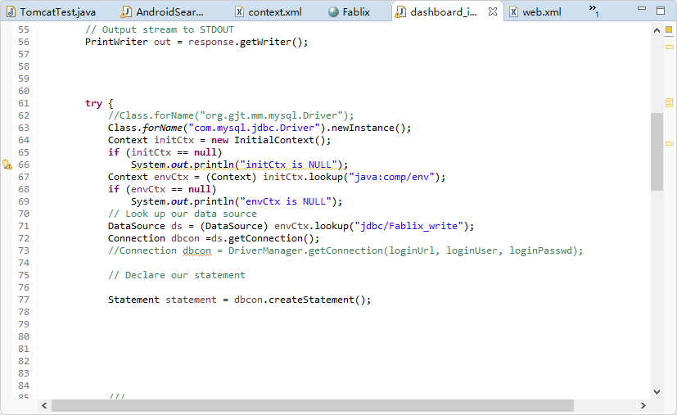

AndroidSearch.java (line 66 to 81)

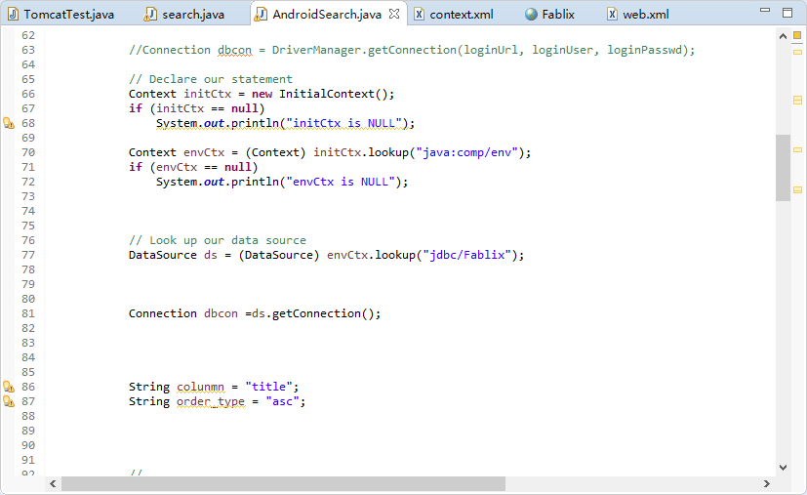

search.java(159,177)

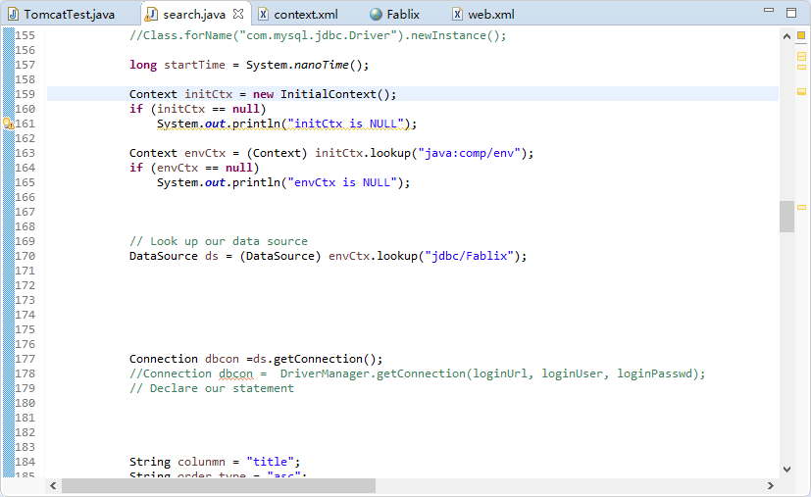

Login.java(65-73)

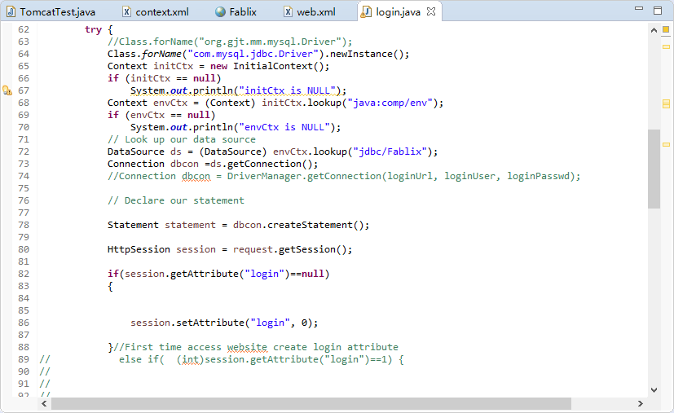

Movie_page.java(120-128)

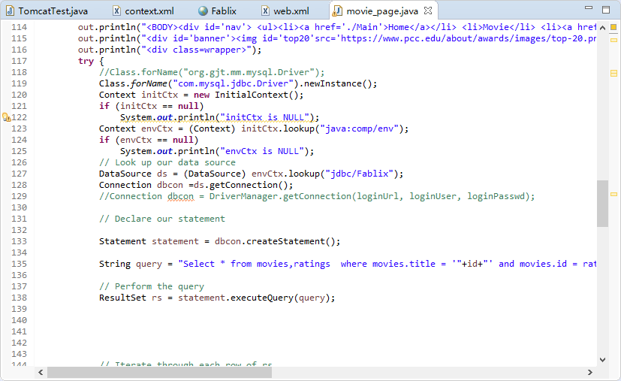

Browse.java(144-152)

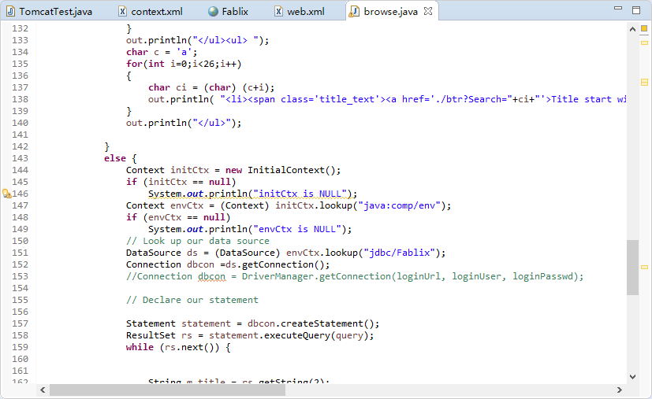

Browse_result.java(130-138)

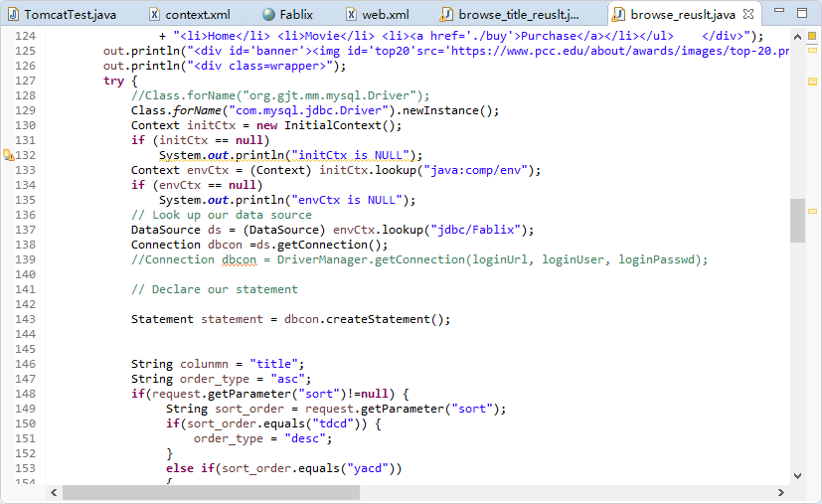

Browse_title_result.java(130-138)

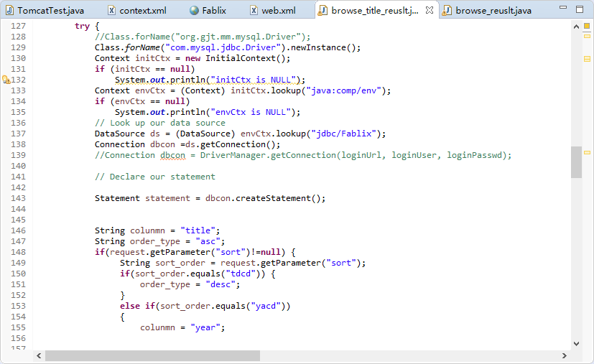

Checkout_auth.java(62-70)

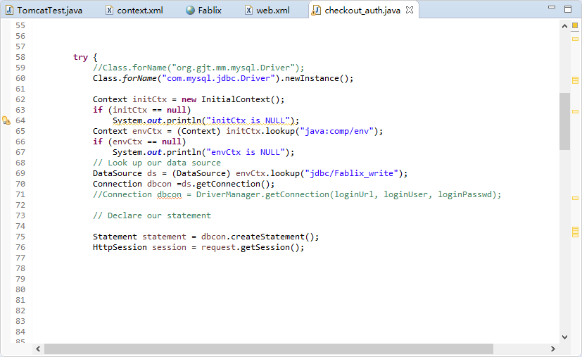

* How did you use Prepared Statements?

Just import sql.perpareStatement in search servlets classes, and change the statement to prepareStatement object.

* File name, line numbers as in Github

src/servlet/search.java

src/servlet/search AndroidSearch.java

src/servlet/search suggestion.java

* Snapshots
* search.java
* line number 231,249,280,293

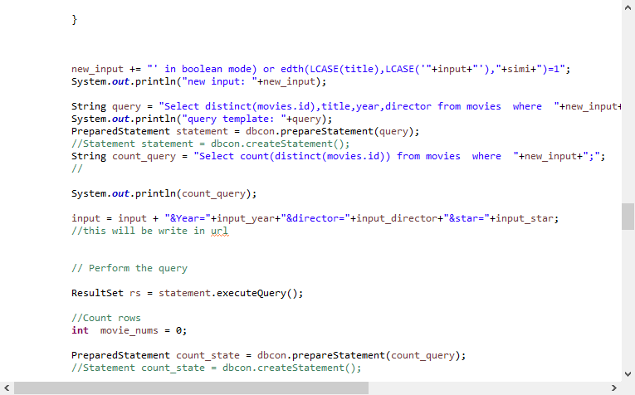

suggestion.java

line number 115, 165

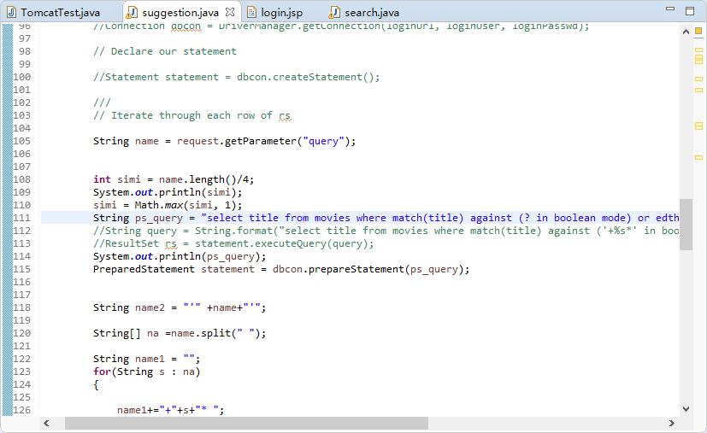

AndroidSearch.java

Line number 124,150,162

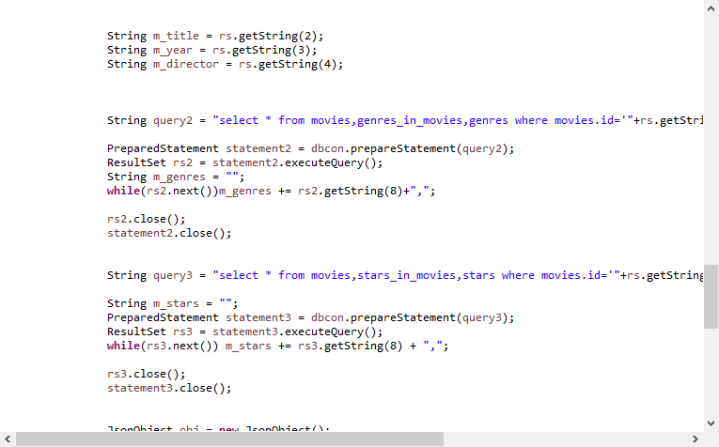

**Task 2**

* Address of AWS and Google instances
* AWS(instance1 origin): 13.58.92.109
* Instance 2(master) : 18.188.135.195
* Instance 3(slave): 18.219.142.40

Google :35.230.4.71

* Have you verified that they are accessible? Does Fablix site get opened both on Google’s 80 port and AWS’ 8080 port?
* Yes they are accessible on both ports
* How connection pooling works with two backend SQL?

Create mysql master on instance1, and slave on instance2, create user on master for the slave to access master’s log file. Set two mysql instances as resource in context file, only mysql on master instance will be map to servlets which send write request.

* + File name, line numbers as in Github

META_INF/Context.xml , all lines.

* + Snapshots
  + 
* How read/write requests were routed?

In the context.xml file I specified two resource, one is dealing read request, another one is dealing write request, write request will only be redirect to master instance because master instance’s IP has been specified in resrource. The writing request will use data_source jdbc/Fablix_write, other servlets will use data source jdbc/Fablix.

* + File name, line numbers as in Github

Context.xml

Line number from 1 - 14

* Snapshots



In dashboard_insert_star.java (line 61- line 77)and dashboard_insert_movie.java(line 65- line 78) I changed data source to Fablix_write

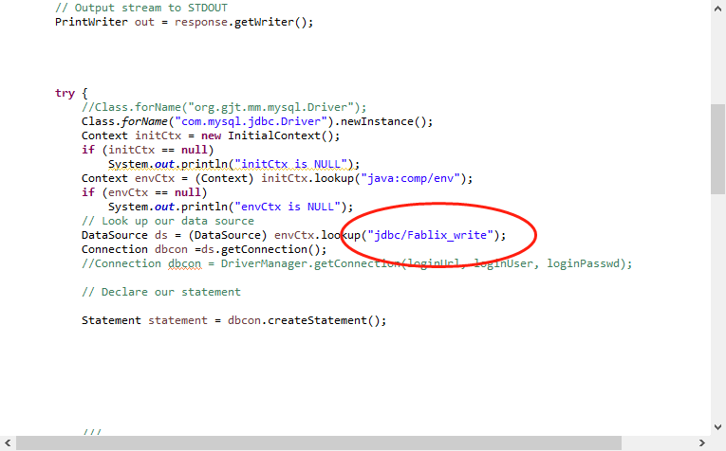

Rest of servlets only sends read requests to mysql, I used jdbc/Fablix source for these servlets.

**Task 3**

* Have you uploaded the log file to Github? Where is it located?

Yes in 122bPJ5 folder

* Have you uploaded the HTML file to Github? Where is it located?

Yes in 122bPJ5 folder

* Have you uploaded the script to Github? Where is it located?

Yes in 122bPJ5 folder

* Have you uploaded the WAR file and README to Github? Where is it located?

Yes in 122bPJ5 folder